**Mid-Term Exam EGR-334 Fall 2018**

**Exam Take Home Due Start of Class Thursday October 11. 2018**

**Analog - Digital Interface**

**Name: _______________________**

**Note: All problems weighted equally. Show your work on all problems to receive partial credit.**

1. **Give an Radio Band of 40 meters λ, Determine the Frequency of Operation in this Band.**

**[Principles of Electronic Communications 4th Edition Chapter 1]**

**a) 7.0 MHz**

**b) 7.03 MHz**

**c) 7.5 MHz**

**d) 7.045 MHz**

1. **Given a Signal that Occupies a Frequency Range from 18.068 MHz to 18.168 MHz Determine the Bandwidth.**

**[Principles of Electronic Communications 4th Edition Chapter 1]**

**a) 50 kHz**

**b) 17.968 MHz**

**c) 100 kHz**

**d) 18.668 MHz**

1. **Given a SSB Transmitter with a 150 V Supply Voltage and a Voice Peak Producing a Current of 2.3 A, Please find the PEP Input.**

**[Amplitude Modulation Fundamentals Chapter 3 pdf]**

**a) 345 W**

**b) 51.75 kW**

**c) 793.5 W**

1. **An AM Broadcast Station Operates with a Carrier Power Pc or 20 kW and 90% Modulation Index, Please Determine the Total Power Pt Delivered by the Radio Station.**

**[Principles of Electronic Communications 4th Edition Chapter 1]**

**a) 28.1 W**

**b) 28.1 kW**

**c) 18.0 kW**

**d) 36.77 kW**

1. **The Signal Level at the Output of an Amplifier is 200 W. The Noise Level at the Output is 1.0 mW. Please Determine the S/N Ratio at the Output of the Amplifier in dB.**

**[The Art of Electronics 3rd Edition Chapter 8]**

**a) 88 dB**

**b) 67 dB**

**c) 53 dB**

**d) 46 dB**

**e) 35 dB**

1. **Given Two BP Bandpass Filters. The First BP Filter allows Frequencies between 24.890 MHz and 24.990 MHz to Pass. The Second BP Filter allows Signals of Frequencies between 24.940 MHz and 25.090 MHz to Pass. Connecting the Two BP Filters in Sequence will Result in the Following Range of Frequencies to Pass on to the Next Stage.**

**[Boylestad 11th Edition Chapter 11]**

**a) 24.890 MHz to 24.940 MHz**

**b) 24.940 MHz to 24.990 MHz**

**c) 24.890 MHz to 24.990 MHz**

**d) 24.940 MHz to 25.090 MHz**

1. **Given the following Bode Plot; Please Determine the Output of the Filter Expressed in Vpp when an Input Signal of 2.5 Vpp is Applied at the Input of the Filter @ Frequency of 5 Hz.**

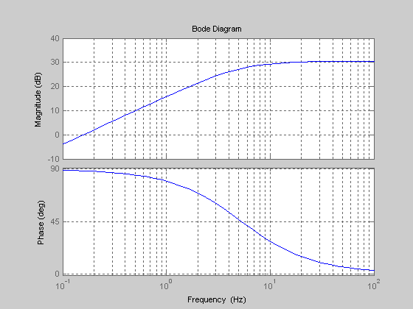

**Vout is Closest to,**

**a) 1.76 Vpp**

**b) 7.90 Vpp**

**c) 5.0 Vpp**

**d) 25.0 Vpp**

**e) 9.33 Vpp**

1. **For the MC1458 Data Sheet Bode Plot Shown Below, Please Determine the Approximate -3 dB Cutoff Frequency.**

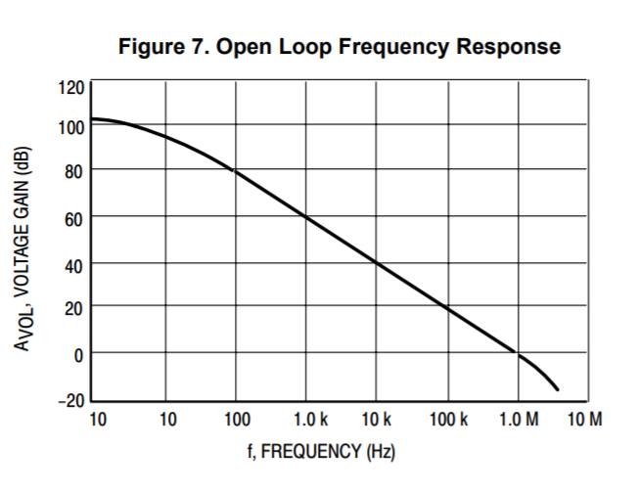

**a) 10 HZ**

**b) 1 MHz**

**c) 2 MHz**

**d) 1.1 MHz**

1. **Referring to the Belden RG58U/1 Coaxial Cable Data Please Determine the Power Output Resulting from an Input Power of 100 W @ 1500 MHz for a Cable 112 Feet in Length.**

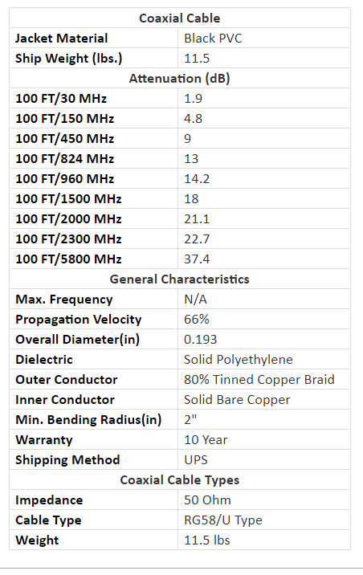

**a) 9.81 W**

**b) 963.82 W**

**c) 963.82 mW**

**d) 963.82 uW**

1. **For a Given Operational Amplifier Please Determine the following Quantities,**

**Amid Voltage Gain = 450 f1 = 125 Hz f2 = 625 Hz**

**Voltage Gain @ 60 Hz**

**a) 188.66**

**b) 28.80**

**c) 194.72**

**d) 13.77**

**Voltage Gain @ 1250 Hz**

**a) 201.24**

**b) 70.70**

**c) 154.77**

**d) 200.60**

**Voltage Gain @ f1 and f2**

**a) 311.23**

**b) 344.98**

**c) 318.15**

**d) 240.66**

1. **For the Bandpass Filter Shown Below, Please Calculate the Following Quantities,**

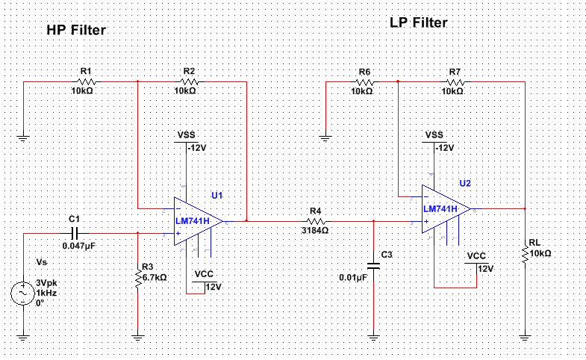

**Lower Cutoff fc**

**a) 1.33 kHz**

**b) 5 Hz**

**c) 500 Hz**

**Upper Cutoff fc**

**a) 5 kHz**

**b) 500 Hz**

**c) 3.88 kHz**

**BW**

**a) 19.8 kHz**

**b) 4.50 kHz**

**c) 20.20 kHz**

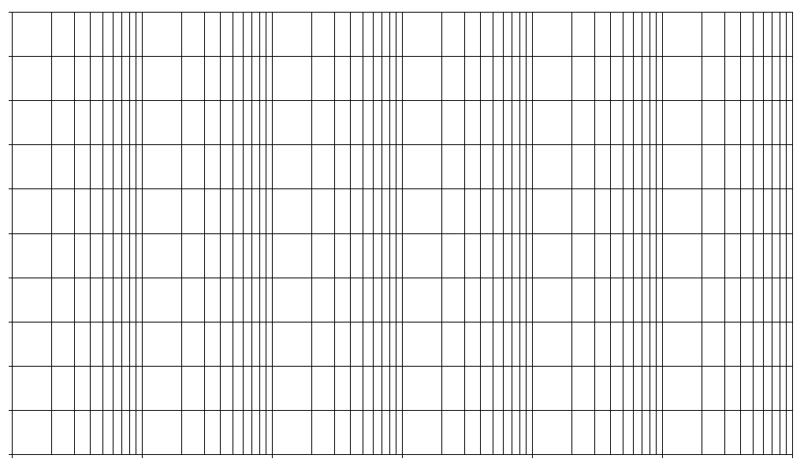

**Assuming the Operational Amplifiers are Operating within Specifications Please Determine the Following,**

**Voutpp @ 100 Hz ____________**

**Voutpp @ 10 kHz ___________**